Program One Part One

//summary This program prints out lines of words to the screen. It's used to practice displaying information

//on the screen

//name: Jenna Wolf

//class: Fundamentals of Programming, CS155 - 01

//instructor: Dr. Art Kazmierczak

//date: 8/23/2023

public class Main

{

public static void main(String[] args)

{

System.out.println("Welcome to CS-500");

System.out.println("Welcome to Computer Science Department");

System.out.println("Programming is fun");

}

}

Output:

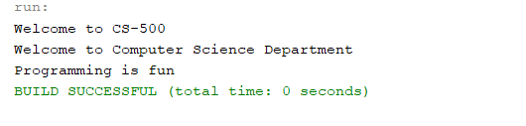

Program One Part Two

//summary This program prints out a equation and its solution.

//name: Jenna Wolf

//class: Fundamentals of Programming, CS155 - 01

//instructor: Dr. Art Kazmierczak

//date: 8/23/2023

public class Main

{

public static void main(String[] args)

{

System.out.println("(9.5 \* 4.5 - 2.5 \* 3) / (45.5 - 3) = ");

System.out.println((9.5 \* 4.5 - 2.5 \* 3) / (45.5 - 3));

}

}

Output:

